**Chalk Talk**: Cell Transport

*AP Biology*

**Cell Transport**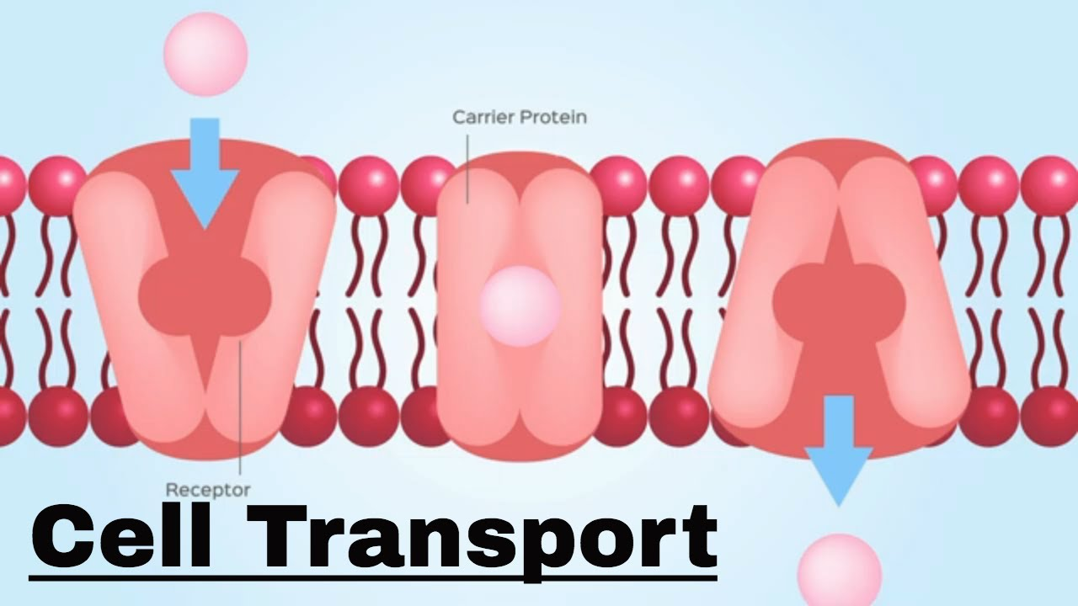

It is the movement of substances across the [cell membrane](https://www.ck12.org/c/life-science/cell-membrane) either into or out of the cell. Sometimes things just move through the [phospholipid bilayer](https://www.ck12.org/c/biology/phospholipid-bilayer). Other times, substances need the assistance of a protein, like a channel protein or some other transmembrane protein, to cross the cell membrane.

Cell transport refers to the movement of substances across the [cell membrane](https://www.ck12.org/c/life-science/cell-membrane). Probably the most important feature of a cell's phospholipid membranes is that they are selectively permeable. A membrane that is selectively permeable, or semipermeable, has control over what molecules or ions can enter or leave the cell, as shown in Figure [below](https://www.ck12.org/biology/cell-transport/lesson/cell-transport-advanced-bio-adv/#x-ck12-QmlvMzMtMDFh). This feature allows a cell to control the transport of materials, as dictated by the cell's function. The permeability of a membrane is dependent on the organization and characteristics of the membrane [lipids](https://www.ck12.org/c/biology/lipids) and [proteins](https://www.ck12.org/c/biology/proteins). In this way, cell membranes help maintain a state of [homeostasis](https://www.ck12.org/c/life-science/homeostasis) within [cells](https://www.ck12.org/c/biology/cells) (and tissues, organs, and organ systems) so that an organism can stay alive and healthy.

The molecular make-up of the [phospholipid bilayer](https://www.ck12.org/c/biology/phospholipid-bilayer) limits the types of molecules that can pass through it. For example, hydrophobic ([water](https://www.ck12.org/c/biology/water)-hating) molecules, such as carbon dioxide (CO2) and oxygen (O2), can easily pass through the lipid bilayer, but ions such as calcium (Ca2+) and [polar molecules](https://www.ck12.org/c/chemistry/polar-molecules) such as [water](https://www.ck12.org/c/biology/water) (H2O) cannot. The hydrophobic interior of the phospholipid bilayer does not allow ions or [polar molecules](https://www.ck12.org/c/chemistry/polar-molecules) through because they are hydrophilic, or water loving. In addition, large molecules such as sugars and [proteins](https://www.ck12.org/c/biology/proteins) are too big to pass through the phospholipid bilayer. Transport proteins within the membrane allow these molecules to cross the membrane into or out of the cell. This way, polar molecules avoid contact with the nonpolar interior of the membrane, and large molecules are moved through large pores.

Every cell is contained within a membrane punctuated with transport proteins that act as channels or pumps to let in or force out certain molecules. The purpose of the transport proteins is to protect the cell's internal environment and to keep its balance of salts, nutrients, and proteins within a range that keeps the cell and the organism alive.

There are four main ways that molecules can pass through a phospholipid membrane. The first way requires no [energy](https://www.ck12.org/c/physics/energy) input by the cell and is called simple [diffusion](https://www.ck12.org/c/life-science/diffusion). This type of transport includes passive diffusion and osmosis. No assistance by transport is necessary for simple [diffusion](https://www.ck12.org/c/life-science/diffusion). Facilitated diffusion, does involve the assistance of transport proteins. The third way, called active transport, requires that the cell uses [energy](https://www.ck12.org/c/physics/energy) to pull in or pump out certain molecules and ions. [Active transport](https://www.ck12.org/c/life-science/active-transport) involves proteins known as *pumps.* The fourth way is through vesicle transport, in which large molecules are moved across the membrane in bubble-like sacks that are made from pieces of the membrane. Vesicular transport includes exocytosis and endocytosis.

**Driving Question**: **How do cells establish and maintain their internal environment?**

**Task**: Using Chalk Markers to construct a model of the cell membrane. Make sure to label and describe the following structures and functions in your model.

|  |  |  |
| --- | --- | --- |
| * Phospholipid (Glycerol, fatty acid tails, phosphate head) * Membrane Proteins (Integral & Peripheral) * Cell Markers (Glycoproteins & Glycolipids) * Saturated vs unsaturated fats * Concentration Gradient * Passive Transport | * Endocytosis * Exocytosis * Diffusion * Aquaporins * Osmosis * Active Transport * Protein Pumps | * Lipid Bilayer * Cholesterol * Aquaporins * Hydrophobic * Hydrophilic * Amphipathic |

**Deliverable**: Take a **picture** of the model, upload it to Google Drive.